***Intelli-Home Electronics Interpreter***

***(IHEI)***

Senior Project Proposal

***Faraz Milani***

***Kelvin Liang***

***Young Min Kim***

***Matthew Cai***

Advisor: Arthur Zhang, GP Li

**TABLE OF CONTENTS**

1. Executive Summary 1

2. Introduction 2

3. background 3-4

4. DEVELOPMENT Plan 5-8

5. schedule and milestones 9

6. deliverables 10

7. team 11-12

8. budget 12

9. References 12

# Executive Summary

The aim of our project is to create a plug load recognition and management system to be used within the average-sized American home. The system will be able to automatically recognize electronic devices that are plugged in throughout the home, and a mobile/web application will allow the homeowners to control the outlets remotely. Once the devices are recognized, the user will be able to easily set personalized schedules using the mobile/web application dictating when specific outlets will be on and off.

There are three main components that make up the Intelli-Home Electronics Interpreter, the first being the outlet module. The outlet module is plugged into an electrical socket within the home, and any electronic devices that are to be controlled plug into this module. The second component of our project is the central hub. This is the gateway of our system, which communicates both with the outlet module and with the user. Lastly, the mobile/web application will allow the user to communicate with the outlet module via the central hub.

Our focus for the project is developing an automatic load recognition algorithm to be implemented within the outlet module. This will allow the user to plug in any variety of electronic devices into the outlet module, and the system will immediately be able to identify the type of device without being explicitly programmed to do so. The automatic recognition algorithm will be based upon a real-time analysis of current waveforms whenever a device is plugged into the module.

All development and testing for this project will be done at UC Irvine, within the California Institute for Telecommunications and Technology (Calit2) CalPlug lab. Our advisor Arthur Zhang is the Technology Manager at CalPlug, providing us with a fully equipped facility suitable for overnight testing and access to multiple PHD students for aid and advice. Two of our team members, Kelvin Liang and Young Min Kim, have a combined previous experience of two years doing research in the CalPlug facility under Arthur, allowing are team to transition into the testing and production phase very quickly.

The deliverables of our project will include (1) a functioning prototype of the system, including a outlet module, central hub, and mobile/web application; (2) a software program for user interface of the mobile/web application; (3) a software program for automatic load recognition; (4) a video displaying personal scheduling feature of the system; (5) a technical report with our plans, test results, algorithm development, and more; (6) a demonstration of our product.

We plan to complete this project within the next two and a half months. Given the fact that the testing and algorithm development for automatic device recognition is already underway, we feel that two and a half months will be sufficient to complete a working prototype of Intelli-Home Electronics Interpreter.

# Introduction

In 1980, the average US home contained approximately 3 consumer electronics devices. Today that number has increased to 25, a number that will continue growing due to constant innovation and high demand for more advanced consumer technology. Consumer electronics and computer equipment currently take up around 15% of electricity consumption globally [1]. The International Energy Agency (IEA) expects the energy use by these types of devices to triple by 2030 if no action is taken to increase energy efficiency.

Plug load devices, any devices/appliances that plug into an electrical outlet, are accountable approximately 20% of the electrical consumption in our households. It is foreseen that the percentage of energy consumption in residential areas due to plug load devices can reach up to 30% by 2030 [2]. Most plug loads draw power even when are idle and not in use, which is extremely energy inefficient. The power that is wasted as an appliance or device is not in use is known as “phantom power”. North America alone wastes $7 billion a year on phantom power [3], which is an obvious problem. As a country that is slowly moving towards the idea of Zero Net Energy (ZNE) homes, houses capable of producing their own energy and consuming very little energy, efforts must be made to lower the energy use of plug load devices.

In our busy daily lives, unplugging devices that are not being used seems very inconvenient, or maybe even impossible. For people who are gone all day at work, parents who are constantly running errands out of the house, and children who can be quite forgetful, making sure to turn off and unplug appliances like chargers, televisions, Blu-ray players, video game consoles etc. is a difficult task. With all the technology available today for wireless connectivity, home automation, and mobile/web applications, there is a great need for an automated system to take care of turning off and unplugging devices that are not in immediate use. Our project aims at creating such a system; one that is able to recognize any basic household plug load and control/schedule its use via a simple mobile/web application. This could greatly cut down the phantom energy waste in homes, leading to electricity bill savings and less stress on the environment for electricity production.

# Background

Home energy management is a popular field today with all the developments in wireless technology and big data, and there is great potential to save a lot of energy, money, and the environment. Many companies are working on systems that interact with utilities companies in order to schedule larger appliances like washing machines and dishwashers around the peak hours of electricity use in order to save homeowners money. However, with the growth of electronic devices per home over the last thirty years and the amount of energy wasted due to these devices, our group is focusing specifically on monitoring plug loads.

Within the scope of managing home plug loads, there has already been some work done by some larger companies and several startup companies. Home security companies such as alarm.com and ADT have created features in their security systems that allow the homeowner to remotely turn on specific outlets or change the temperature on the thermostat in the house via mobile applications. However, with most home security companies a monthly subscription fee for the service is required, which is not ideal for people looking for a cheap and easy way to manage their plug load power use.

For those who are interested in simply controlling the activity of their electrical outlets around the house, a few startup companies have created simpler and cheaper solutions. Ninja Blocks and Valta, for example, have designed energy management systems that allow users to turn specific plug loads around the house on and off and personalized create scheduling systems that turn devices on and off based on the time of the day. These products’ system architecture includes a base station that communicates with their outlet adapters, which the devices are plugged into. Other products such as Belkin’s WeMo Insight Switch have outlet adapters that communicate directly with the mobile application that comes with the product, instead of having a base station that controls the wireless communication. The products mentioned above use wireless protocols such as RF 433.92 Mhz, ISM frequency band, and WiFi.

While the products on the market today have on/off and scheduling capabilities for plug load control, there are many features that need improvement. The main downfall to the plug load management systems on the market is that they are not user-friendly to those who lack technical knowledge. The products above require the user to plug their device into the outlet adapter and program which device corresponds to each wall adapter that they purchase, which is too much to ask for the common non-technical homeowner.

# COMPETITIVE ADVANTAGES

Our product aims to make managing plug loads simple for the typical homeowner by implementing a real-time automatic device recognition feature. This means that the user can plug in any of their household devices into our module, and the system will instantly recognize the device connected. Intelli-Home Electronics Interpreter bypasses the manual programming of each outlet adapter stage that other products require, making the process simple and quick.

**HP Laptop**

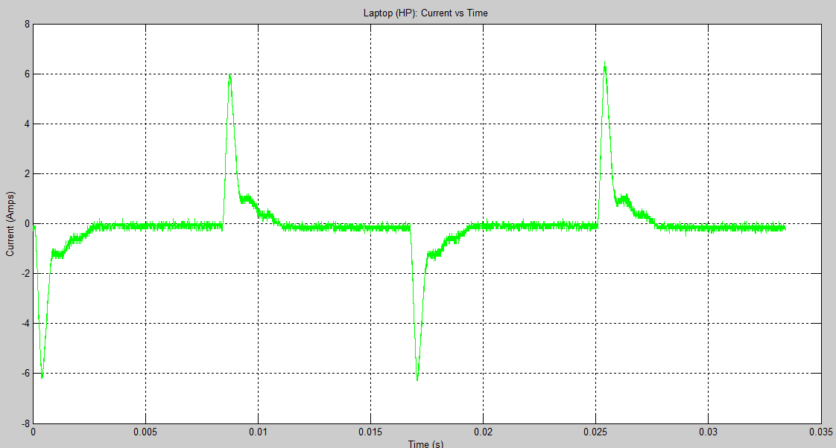

**Direct TV Set-Top Box**

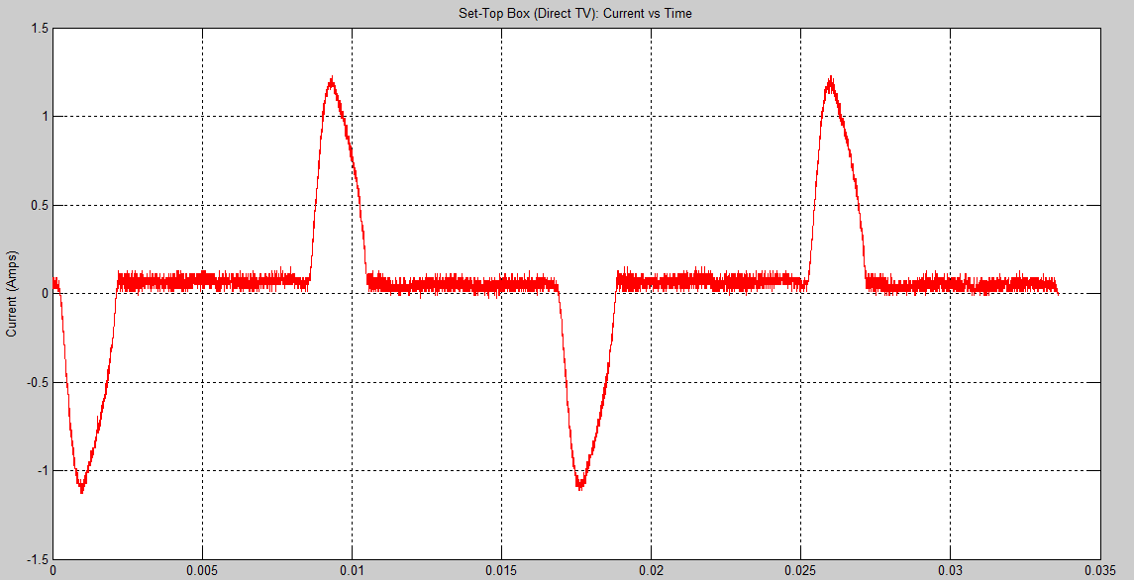

**Sharp TV**

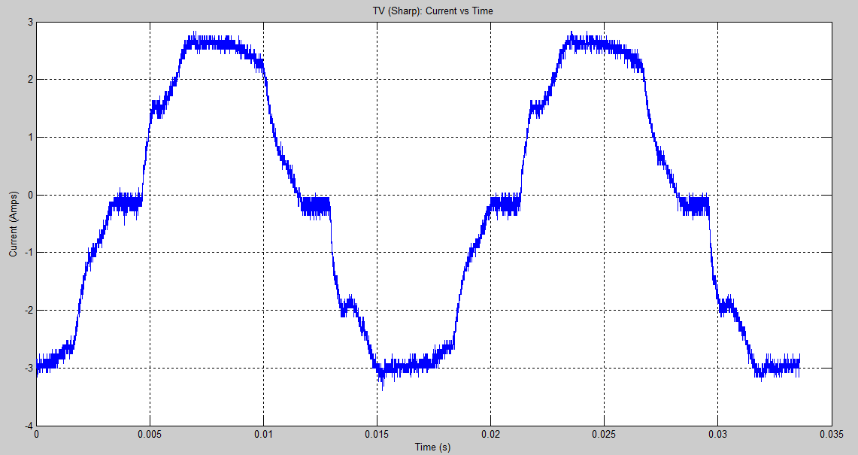

*Figure 1: Current Vs. Time Waveforms for (a) HP Laptop (b) Direct TV Set-Top Box (c) Sharp TV*

# By using digital signal processing techniques at the outlet module level, we have begun developing and testing the automatic recognition algorithm. As shown in the diagrams below, we are currently collecting data about the current vs. time waveforms of common household devices such as laptops and televisions sets. When we complete the analysis of all the basic home appliances and devices, our hope is to make the user experience as smooth as plugging in a device and moments later getting a notification on their phone or web application recognizing the correct device.Development Plan

We will be developing a system that automatically recognizes devices plugged into our outlet module and sends the device information wirelessly to a mobile/web application via the central hub. There basic system architecture of our product is displayed below:

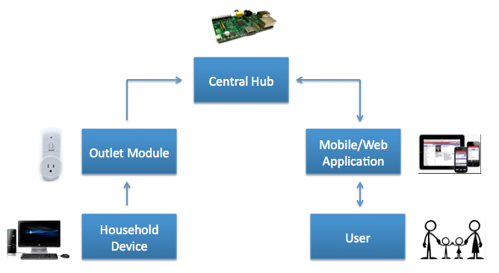

**1. Outlet Module**

The outlet module is plugged into an electrical outlet, following which the user’s device is plugged into the outlet module. Our module uses these components:

* TI CC2530 SoC 2.4 GHz IEEE 802.15.4/RF4CE/ZigBee
* SmartRF05 Evaluation Board
* Outlet Adapter

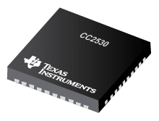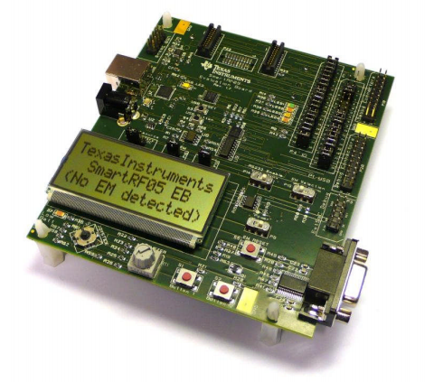 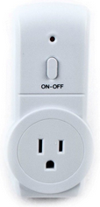

*CC2530 SmartRF05 Outlet Adapter*

**2. Central Hub**

The central hub is the gateway between the outlet module and the user. Data regarding scheduling or profiles will also be stored here.

* Raspberry Pi Model B
* USB-CID - ZigBee USB Interface
* WiFi USB Dongle

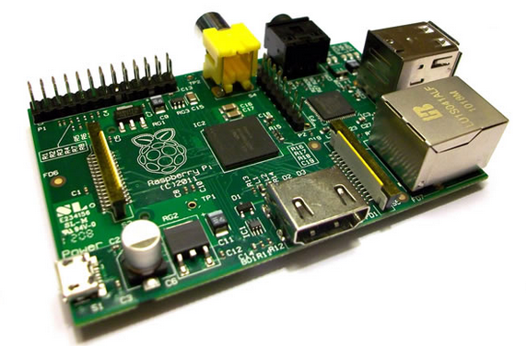 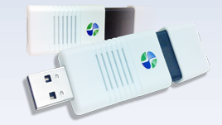 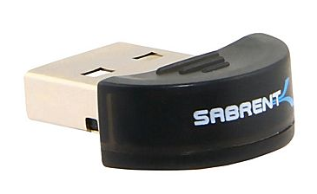

*Raspberry Pi USB-CID-ZigBee WiFi USB Dongle*

**3. Mobile/Web Application**

The Android mobile and web application is the user interface for our system. It will allow the user to interact with their devices with on/off and personalized scheduling features.

**The Outlet Module**

Current Measurement

The outlet module is comprised of a TI CC2530 microcontroller connected to an outlet adapter in such a way that we are able to measure the AC current being drawn by the device when the outlet module is plugged into an electrical socket, and the device is plugged into the module. The microcontroller acts as a mini oscilloscope, measuring current vs. time.

Automatic Load Recognition

After testing different methods for characterizing devices such as the analysis of active and reactive power, harmonics, current waveforms, and instantaneous power waveforms, we came to the conclusion that the best way to differentiate between different devices is by looking at the current vs. time waveform. The TI CC2530 acts as a digital signal processor by sampling the current waveform real time. The automatic device recognition algorithm is implemented on the TI CC2530, gathering data such as amplitude, rise time, fall time, etc. This data is then compared with a database of device profiles, and is matched with the device that has the closest waveform characteristics.

Connectivity

We have chosen the TI CC2530 to do our signal processing due to the fact that it is a strong machine that is ZigBee enabled. We want to use the Zigbee wireless protocol due to the fact that it is low power and low cost, and very common is smart homes. Because we the goal of our project is to save energy within the average household, it only makes sense that our system is low power and relatively cheap.

**The Central Hub**

Connectivity

The central hub for our product is a Raspberry Pi Model B device. This is a mini WiFi enabled Linux computer that is sold at an affordable price. Being the gateway of the system, the Raspberry Pi will communicate with not only the wall module (TI CC2530), but also the user’s mobile/web application. We chose this specific device as our central hub not only because it is extremely cheap, but also for the USB ports that can allow for different wireless connectivity protocols as well as the large amount of documentation regarding connecting the Raspberry Pi to different microcontrollers or mobile applications. Our plan is to connect Zigbee and WiFi USB dongles to the hub, allowing data to be sent from the wall module to the Raspberry Pi via ZigBee, and then from the Raspberry Pi to the mobile/web application via WiFi. We chose to use WiFi for communication between the mobile/web application and the central hub because the majority of American homes are WiFi enabled. Also, there is large amount of data and many tools available for interfacing user applications and the Raspberry Pi.

Data Storage

The Raspberry Pi has 512 MB of RAM, allowing for storage of data on the central hub. Data regarding personalized scheduling will be stored on the Raspberry Pi.

**The Mobile/Web Application**

Android App.

The mobile/web applications we plan to build will be Android based, due to our teams experience in creating Android mobile applications and the fact that it is open-source. Also, once we create a mobile application, creating a very similar web application will not be too time consuming. The key features will be:

* Simplistic yet attractive design
* Dashboard with the automatically detected devices
* Manual Mode and Scheduling Mode
* Manual Mode will allow the user to simply switch on/off their device remotely
* Scheduling Mode will allow the user to create a schedule dictating which devices will be on/off throughout the whole day based on the time of the day
* User will be able to save Profiles, meaning schedules that they want to reuse on special occasions such as vacation, long days at work, etc.

**Summary of Hardware Components**

* TI CC2530 Microcontroller
* SmartRF05 Evaluation Board
* Outlet Adapter
* Raspberry Pi
* WiFi and Zigbee USB dongles

**Summary of Software Components**

* Android mobile/web application front end software
* Software interfacing Raspberry Pi with TI CC2530 via ZigBee
* Software interfacing mobile/web application with Raspberry Pi via WiFi
* Automatic Load Recognition software

**Prototypes and Testing**

We plan on having three prototypes for our product:

1. The first prototype will demonstrate the ability of the system to recognize a device, and communicate that data to the Raspberry Pi via ZigBee. We will test this using the SmartRF05 Evaluation board and the Raspberry Pi.
2. The second prototype will send the data from the Raspberry Pi to the user mobile/web application, allowing the user to see their connected device on their phone or computer.
3. The third prototype is the final product, allowing the user on/off and scheduling capability.

The test equipment we will be using for our project is listed below:

* Oscilloscope
* Power Supply
* Digital Voltmeter
* SmartRF05 Evaluation Board

# Schedule and milestones

We have just around two and a half months to complete our project, meaning time must be allocated wisely in order to finish in time. The main tasks for our project include:

1. Testing and characterization of different plug loads—this process takes a long time per device, so we must devote at least 5-10 hours per week
2. Device Recognition Algorithm—debugging an algorithm is quite time consuming as well, so we must spend around 5-10 hours per week
3. Interfacing between devices—this should begin in the first few weeks to ensure that our system is going to run smoothly, requires around 5-10 hours per week
4. User Interface and Front End Software—user interface should not be too difficult, but the front end software can take some time to debug, requires around 5-10 hours per week

The important milestones for Intelli-Home Electronics Interpreter are listed below:

|  |  |
| --- | --- |
| **Date Completed** | **Milestones** |
| 11/25/2013 | Scope/topic determined |
| 12/9/2013 | Core design completed |
| 1/6/2014 | Complete UI for mobile/web app. |
| 1/13/2014 | Demonstrate interfacing between mobile/web app. and RPi |
| 1/20/2014 | Demonstrate interfacing between ZigBee microcontroller and RPi Hub |
| 1/27/2014 | Prototype 1: Demonstrate load recognition for basic devices, send this data to RPi |
| 2/3/2014 | Prototype 2: Demonstrate, using ZigBee microcontroller, RPi, and mobile/web app. to recognize load and turn on/off |
| 2/10/2014 | First draft of scheduling feature on mobile/web app. completed |
| 2/17/2014 | Prototype 3: Complete system capable of automatic recognition, with on/off and scheduling features on mobile/web app. completed |
| 2/24/2014 | Final tests/modifications |
| 3/3/2014 | Oral presentation to industrial panel |
| 3/10/2014 | Turn in final report |

# deliverables

The deliverables that we will provide by March 10th, 2014 are listed below.

1. A working prototype unit that does these following:
   1. Automatic identification of devices using waveform characteristics by:
      1. Sampling characteristic features of the device, such as their current behavior
      2. Implementing an algorithm using the collected information about the device
2. A software program in the form of an mobile application that does the following:
   1. Communicates to the central hub that has stored information about the device and scheduling
   2. Provides a user-friendly interface that:
      1. Recognizes the type of device under use
      2. Allows the user to enable manual control or scheduling of devices
3. A technical report that provides
   1. Plans and description
      1. Concepts and implementation of load signatures
   2. Technical specifications of the hardware used on the working prototype
   3. Software strategy for
      1. The algorithm for automatic identification
      2. Mobile/web application (Android)
   4. Results of testing
      1. Load signatures of devices to be identified
4. A working demonstration of the working prototype implemented in a typical, model home in the form of a time-elapsed video

# our Team

Group Leader: Faraz Milani

Faraz Milani is a 4th year Electrical Engineering major. He is in charge of the overall progress of the project, system architecture, and keeping constant contact with advisor Arthur Zhang to ensure the success of our project. As group leader, Faraz is responsible for guiding the team and making sure that the team meets the deliverables at each milestone. Faraz’s years of broad professional work experience include software, applications, and technical engineering internships at companies such as Outward Inc, Aptina Imaging, and Sandforce Inc. At his internships, he developed algorithms for image processing, and has scripted in languages such as Perl for testing of sensors and solid state drives. Faraz is currently the Vice President of Author Relations for Layers, a new enhanced e-book platform. He also serves as Vice President of Eta Kappa Nu, the electrical engineering and computer science honors society. He contributes a team oriented mindset that is paired with his vast leadership experience.

Hardware Specialists: Kelvin Liang and Young Min Kim

Kelvin Liang and Young Min Kim are both 4th year Electrical Engineering majors. Together, they are responsible for the hardware-related aspects of the project, such as interfacing between current sensors and microcontrollers, and digital signal processing for device recognition. They both currently intern as Hardware Engineers at Broadcom Corporation and have a combined 2 years of experience working there. Their internships currently require them to script and interface test equipment such as spectrum analyzers, RF switches, oscilloscopes, and signal generators. Other tasks include PCB board design, cost and component optimization of evaluation boards, and matching circuit design. In the team, they contribute vast knowledge of digital communications, digital signal processing, and hardware and circuit design. Prior to working at Broadcom, Kelvin and Young both spent a year researching under our current Advisor, Dr. Arthur Zhang. They are most familiar with the needs and goals of the project.

Software Specialist: Matthew Cai

Matthew Cai is a 4th year Computer Engineering major. In this team, he is responsible for creating the user interface for the mobile application and programming the microcontrollers. Matthew has working knowledge in C++, C, Java, VHDL, HTML, C#, MIPS, JavaScript, PHP, and SQL. He has applied these skills in numerous projects which include creating his own rendition of the popular Pac-Man game, and developing PHP scripts for web crawling. Matthew’s years of professional experience include software engineering internships at companies such as Arbonne, Kaarma, and Novak. On his free time, he participates in programming competitions such as the AppJam, and LA Hacks.

Advisor: Arthur Zhang, Technology Manager at CalPlug

Arthur manages technology strategies and applications for the CalPlug Center at Calit2. He works closely with policy makers, manufacturers, faculty and researchers to promote plug load energy efficiency. Arthur is actively involved with technology commercialization of cutting edge products in energy efficiency, telecommunications, and micro devices for medical and industrial applications. Before joining Calit2, Zhang was the project leader for several industry and government funded R&D projects and developed record-breaking prototypes at the Integrated Nanosystems Research Facility. Zhang publishes his work at leading conferences and  
journals for IEEE and APS. Yang received his B.S. degree in Applied Physics with honors from the University of Science and Technology of China. His Ph.D. work in experimental plasma physics from the University of California, Irvine was supported by a Regents’ Fellowship and a Department of Energy grant.

**BUDGET**

|  |  |  |
| --- | --- | --- |
| **Item** | **Percent (%)** | **Cost ($)** |
| Salaries | 0 | 0 |
| Raspberry Pi | 3.9 | 40 |
| ZigBee SoC’s and Boards | 88.2 | 900 |
| Wall adapters | 1.96 | 20 |
| WiFi/Zigbee USB sticks | 7.8 | 80 |
|  |  |  |
| Total | 100 | 1040 |

**REFERENCES**

1. "Other FAQs." *IEA*. International Energy Agency, 10 Mar. 2012. Web. 10 Dec. 2013.
2. "Newsroom: Highlights." *Calit2@UCI*. CalPlug, n.d. Web. 10 Dec. 2013. <http://www.calit2.uci.edu/calit2-newsroom/itemdetail.aspx?cguid=8d8138bd-12a3-4767-8d4e-daec37797275>.
3. "North American Households Waste $7 Billion Annually in Phantom Power According to E Source Plug Load Research." *Tools, Research Services, and Advice for Utilities and Corporations*. E Source, n.d. Web. 10 Dec. 2013. <http://www.esource.com/ES-PR-PlugLoads-12-12/Press-Release/PlugLoads>.